WEEK 6

1. ReactJS

App.js

import React from 'react';

function App() {

  return (

    <div>

      <h1>Welcome to the first session of React</h1>

    </div>

  );

}

export default App;

Output:

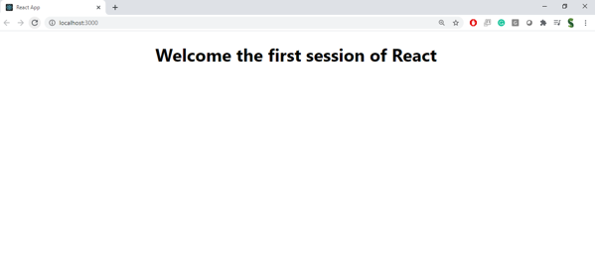

1. ReactJS

Home.js

import React from 'react';

class Home extends React.Component {

  render() {

    return <h2>Welcome to the Home page of Student Management Portal</h2>;

  }

}

export default Home;

About.js

import React from 'react';

class About extends React.Component {

  render() {

    return <h2>Welcome to the About page of Student Management Portal</h2>;

  }

}

export default About;

Contact.js

import React from 'react';

class Contact extends React.Component {

  render() {

    return <h2>Welcome to the Contact page of Student Management Portal</h2>;

  }

}

export default Contact;

App.js

import React from 'react';

import Home from './Components/Home';

import About from './Components/About';

import Contact from './Components/Contact';

function App() {

  return (

    <div>

      <Home />

      <About />

      <Contact />

    </div>

  );

}

export default App;

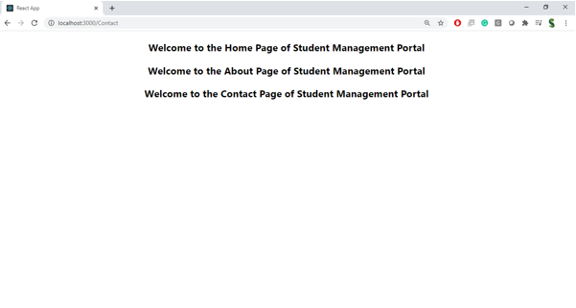

1. ReactJS

Style.css

.container {

  background-color: #f2f2f2;

  padding: 20px;

  border-radius: 10px;

}

h2 {

  color: darkblue;

}

CalculateScore.js

import React from 'react';

import '../Stylesheets/style.css';

function CalculateScore(props) {

  const name = 'Rithi';

  const school = 'Sathyabama University';

  const total = 450;

  const goal = 500;

  const average = (total / goal) \* 100;

  return (

    <div className="container">

      <h2>Student Score Details</h2>

      <p><strong>Name:</strong> {name}</p>

      <p><strong>School:</strong> {school}</p>

      <p><strong>Total:</strong> {total}</p>

      <p><strong>Goal:</strong> {goal}</p>

      <p><strong>Average Score:</strong> {average.toFixed(2)}%</p>

    </div>

  );

}

export default CalculateScore;

App.js

import React from 'react';

import CalculateScore from './Components/CalculateScore';

function App() {

  return (

    <div>

      <CalculateScore />

    </div>

  );

}

export default App;

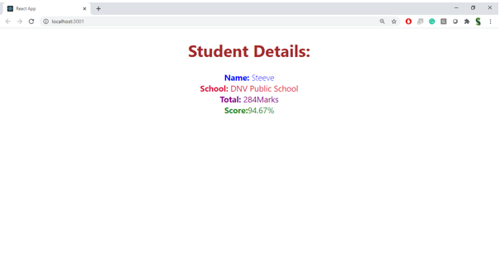

1. ReactJS

Posts.js  
import React, { Component } from 'react';

class Posts extends Component {

  constructor(props) {

    super(props);

    this.state = {

      posts: [],

      error: null

    };

  }

  componentDidMount() {

    this.loadPosts();

  }

  loadPosts = () => {

    fetch('https://jsonplaceholder.typicode.com/posts')

      .then(res => res.json())

      .then(data => this.setState({ posts: data }))

      .catch(err => this.setState({ error: err.message }));

  }

  componentDidCatch(error, info) {

    alert("An error occurred: " + error);

  }

  render() {

    const { posts, error } = this.state;

    return (

      <div>

        <h2>Post List</h2>

        {error && <p>Error: {error}</p>}

        {posts.map(post => (

          <div key={post.id}>

            <h3>{post.title}</h3>

            <p>{post.body}</p>

          </div>

        ))}

      </div>

    );

  }

}

export default Posts;

App.js

import React from 'react';

import Posts from './Posts';

function App() {

  return (

    <div>

      <Posts />

    </div>

  );

}

export default App;

1. ReactJS

CohortDetails.module.css

.box {

  width: 300px;

  display: inline-block;

  margin: 10px;

  padding: 10px 20px;

  border: 1px solid black;

  border-radius: 10px;

}

dt {

  font-weight: 500;

}

CohortDetails.js  
import React from 'react';

import styles from './CohortDetails.module.css';

function CohortDetails({ name, status }) {

  const titleStyle = {

    color: status === 'ongoing' ? 'green' : 'blue'

  };

  return (

    <div className={styles.box}>

      <h3 style={titleStyle}>{name}</h3>

      <dl>

        <dt>Status:</dt>

        <dd>{status}</dd>

      </dl>

    </div>

  );

}

export default CohortDetails;

App.js

import React from 'react';

import CohortDetails from './CohortDetails';

function App() {

  return (

    <div>

      <CohortDetails name="React Bootcamp" status="ongoing" />

      <CohortDetails name="Java Basics" status="completed" />

    </div>

  );

}

export default App;

